ATPHY Narrogin SHS 2021: The program that follows provides a guide of the timing for the delivery of the required content. As per usual, times may change due to extenuating circumstances.

UNIT 3

Gravity and motion

Artificial satellites are used for communication, navigation, remote-sensing and research. Their orbits and uses are classified by altitude (low, medium or high Earth orbits) and by inclination (equatorial, polar and sun-synchronous orbits). Communication via satellite is now used for global positioning systems (GPS), satellite phones and television. Navigation services support management and monitoring of traffic and aircraft movement. Geographic information science uses data from satellites to monitor population movement, biodiversity and ocean currents.

1. Term 1 Week 1 (Wk 1)
Content | Text | Qns | Assessments
Gravity and motion  - the movement of free-falling bodies in Earth’s gravitational field is predictable  - objects with mass produce a gravitational field in the space that surrounds them; field theory attributes the gravitational force on an object to the presence of a gravitational field  This includes applying the relationship  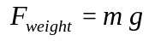  - when a mass moves or is moved from one point to another in a gravitational field and its potential energy changes, work is done on the mass by the field  This includes applying the relationships  - the vector nature of the gravitational force can be used to analyse motion on inclined planes by considering the components of the gravitational force (that is, weight) parallel and perpendicular to the plane | Chapter 1  p.4 –16 | Set 1.1  Set 1.2

2. Term 1 Week 2 (Wk 2)
Content | Text | Qns | Assessments
- projectile motion can be analysed quantitatively by treating the horizontal and vertical components of the motion independently  This includes applying the relationships  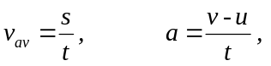 | Chapter 1  p.16 - 20 | Set 1.3

3. Term 1 Week 3 (Wk 3)
Content | Text | Qns | Assessments
- when an object experiences a net force of constant magnitude perpendicular to its velocity, it will undergo uniform circular motion, including circular motion on a horizontal plane and around a banked track; and vertical circular motion  This includes applying the relationships  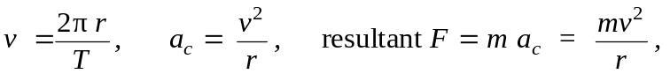 | Chapter 1  p.21 - 31 | Set 1.4 | Task 1: Circular Motion Investigation with in-class validation (5%)

4. Term 1 Week 4 (Wk 4)
Content | Text | Qns | Assessments
- when an object experiences a net force at a distance from a pivot and at an angle to the lever arm, it will experience a torque or moment about that point  This includes applying the relationship  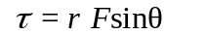 | Chapter 1  p.32- 37

5. Term 1 Week 5 (Wk 5)
Content | Text | Qns | Assessments
- for a rigid body to be in equilibrium, the sum of the forces and the sum of the moments must be zero  This includes applying the relationships | Chapter 1  p.38 - 40 | Set 1.5  Chapter 1 Review Q’s on p.42-44 | Task 5: Two Dimension Motion Test (6%)

6. Term 1 Week 6 (Wk 6)
Content | Text | Qns | Assessments
- all objects with mass attract one another with a gravitational force; the magnitude of this force can be calculated using Newton’s Law of Universal Gravitation  This includes applying the relationship  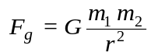  - gravitational field strength is defined as the net force per unit mass at a particular point in the field  This includes applying the relationships  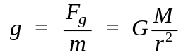 | Chapter 2  p.46 - 59 | Set 2.1  Set 2.2  Set 2.3

7. Term 1 Week 7 (Wk 7)
Content | Text | Qns | Assessments
- Newton’s Law of Universal Gravitation is used to explain Kepler’s laws of planetary motion and to describe the motion of planets and other satellites, modelled as uniform circular motion  This includes deriving and applying the relationship  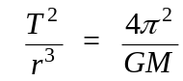 | Chapter 2  p.62 – 67 | Set 2.4  Chapter 2 Review Q’s on p.69-70 | Task 6: Gravity and Equilibrium Test (6%)

Electromagnetism

Electromagnetism is utilised in a range of technological applications, including:

- DC electric motor with commutator, and back emf
- AC and DC generators
- transformers
- regenerative braking
- induction hotplates
- large scale AC power distribution systems

8. Term 1 Week 8 (Wk 8)
Content | Text | Qns | Assessments
Electromagnetism  - a positively charged body placed in an electric field will experience a force in the direction of the field; the strength of the electric field is defined as the force per unit charge  This includes applying the relationship  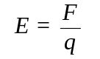  - point charges and charged objects produce an electric field in the space that surrounds them; field theory attributes the electrostatic force on a point charge or charged body to the presence of an electric field | Chapter 3  p.72 – 81 | Set 3.1

9. Term 1 Week 9. (Wk 9)
Content | Text | Qns | Assessments
- electrostatically charged objects exert a force upon one another; the magnitude of this force can be calculated using Coulomb’s Law  This includes applying the relationship  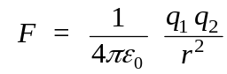  - when a charged body moves or is moved from one point to another in an electric field and its potential energy changes, work is done on the charge by the field  This includes applying the relationship  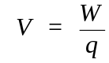 | Chapter 3  p.82–91 | Set 3.2  Set 3.3  Chapter 3 Review Q’s on p.92-94

10. Term 1 Week 10 (Wk 10)
Content | Text | Qns | Assessments
- the direction of conventional current is that in which the flow of positive charges takes place, while the electron flow is in the opposite direction  - magnets, magnetic materials, moving charges and current-carrying wires experience a force in a magnetic field when they cut flux lines; this force is utilised in DC electric motors and particle accelerators  This includes applying the relationships   | Chapter 4  p.96–104 | Set 4.1

11. Term 2 Week 1 (Wk 11)
Content | Text | Qns | Assessments
- current-carrying wires are surrounded by magnetic fields; these fields are utilised in solenoids and electromagnets  - the strength of the magnetic field produced by a current is a measure of the magnetic flux density  This includes applying the relationship  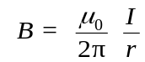 | Chapter 4  p.105 –118 | Set 4.2  Chapter 4 Review Q’s on p.121-122

12. Term 2 Week 2 (Wk 12)
Content | Text | Qns | Assessments
- magnetic flux is defined in terms of magnetic flux density and area  This includes applying the relationship    - an induced emf is produced by the relative motion of a straight conductor in a magnetic field when the conductor cuts flux lines  This includes applying the relationship  where 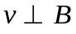  - a changing magnetic flux induces a potential difference; this process of electromagnetic induction is used in step-up and step-down transformers, DC and AC generators  This includes applying the relationships  - conservation of energy, expressed as Lenz’s Law of electromagnetic induction, is used to determine the direction of induced current. | Chapter 5  p.124 – 126  Chapter 5  p.127 – 130 | Set 5.1 | Task 2: Evaluation and Analysis – Unit 3 Content – in-class hypothetical data evaluation and analysis (5%)

13. Term 2 Week 3 (Wk 13-14)
Content | Text | Qns | Assessments
- the force due to a current in a magnetic field in a DC electric motor produces a torque on the coil in the motor  This includes applying the relationship  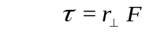  - a changing magnetic flux induces a potential difference; this process of electromagnetic induction is used in step-up and step-down transformers, DC and AC generators  This includes applying the relationships  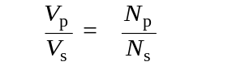  -  | Chapter 5  P 134 – 151. | Set 5.2  Set 5.3  Set 5.4  Chapter 5 Review Q’s p.161-163 | Task 7: Electricity and Magnetism Test (6%)

14. Term 2 Week 4 (Wk 14)
Content | Text | Qns | Assessments
- Non-assessment week – revision for examination

15. Term 2 Week 5 (Wk 15)
Content | Text | Qns | Assessments
Semester 1 Examination (Unit 3 content only) |  |  | Task 10: Semester 1 Examination (20%)

UNIT 4

Special relativity

Research studies of cosmic rays show that interactions between cosmic rays and the upper atmosphere produce muons. These particles have a lifetime of about two microseconds and should have ceased to exist before reaching the surface of the Earth. However, because they are travelling near the speed of light, the time dilation effect allows them to complete their journey. Continuing research in the field of high-energy physics is important for improving our understanding of our world and its origins.

1. Term 2 Week 6 (Wk 16)
Content | Text | Qns | Assessments
Special relativity  - motion can only be measured relative to an observer; length and time are relative quantities that depend on the observer’s frame of reference  This includes applying the relationships  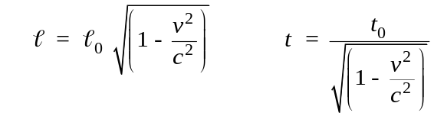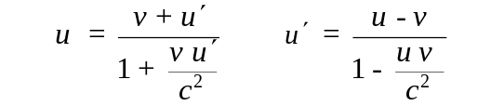  - the special theory of relativity is based on two postulates: that the speed of light in a vacuum is an absolute constant, and that all inertial reference frames are equivalent | Chapter 6  p.166 - 185 | Set 6.1  Set 6.2  Set 6.3

2. Term 2 Week 7 (Wk 17)
Content | Text | Qns | Assessments
- observations of objects travelling at very high speeds cannot be explained by Newtonian physics. These include the dilated half-life of high-speed muons created in the upper atmosphere, and the momentum of high-speed particles in particle accelerators  - Einstein’s special theory of relativity predicts significantly different results to those of Newtonian physics for velocities approaching the speed of light | Chapter 6  p.186 - 190 | Set 6.4

3. Term 2 Week 8 (Wk 18)
Content | Text | Qns | Assessments
- relativistic momentum increases at high relative speed and prevents an object from reaching the speed of light  This includes applying the relationship  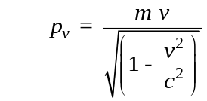 | Chapter 6  p.191 - 195

4. Term 2 Week 9 (Wk 19)
Content | Text | Qns | Assessments
- the concept of mass-energy equivalence emerged from the special theory of relativity and explains the source of the energy produced in nuclear reactions  This includes applying the relationship  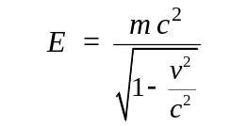 | Chapter 6  p.196 - 198 | Set 6.5  Chapter 6 Review Q’s on p.200-202

Wave particle duality and the quantum theory

Models that were initially rejected can be revisited as more evidence becomes available. For many years, the presence of the luminiferous ether was proposed as the medium by which light is propagated. Around 1800, Thomas Young showed through experimentation that light passing through a double slit showed interference and thus wave properties. The wave explanation of Young’s double slit demonstration was initially rejected until other physicists, including Fresnel and Poisson, showed that light was able to undergo diffraction, a property of waves. Later, in the 1860s, James Clerk Maxwell developed a theory of electromagnetism and showed that electromagnetic waves would travel through space at the speed of light, implying light was an electromagnetic wave.
The use of devices developed from the application of quantum physics, including the laser and photovoltaic cells, have significantly changed many aspects of society.

5. Term 2 Week 10 (Wk 20) - Countryweek
Content | Text | Qns | Assessments
Wave particle duality and the quantum theory  - light exhibits many wave properties; however, it cannot only be modelled as a mechanical wave because it can travel through a vacuum  - a wave model explains a wide range of light-related phenomena, including reflection, refraction, dispersion, diffraction and interference; a transverse wave model is required to explain polarisation  - oscillating charges produce electromagnetic waves of the same frequency as the oscillation; electromagnetic waves cause charges to oscillate at the frequency of the wave  - electromagnetic waves are transverse waves made up of mutually perpendicular, oscillating electric and magnetic fields. | Go Back to Chapter 5  p.152 - 157 | Set 5.5

6. Term 3 Week 1 (Wk 21)
Content | Text | Qns | Assessments
- atomic phenomena and the interaction of light with matter indicate that states of matter and energy are quantised into discrete values  - on the atomic level, electromagnetic radiation is emitted or absorbed in discrete packets called photons. The energy of a photon is proportional to its frequency. The constant of proportionality, Planck’s constant, can be determined experimentally using the photoelectric effect and the threshold voltage of coloured LEDs  This includes applying the relationships  - a wide range of phenomena, including black body radiation and the photoelectric effect, are explained using the concept of light quanta | Chapter 7  p.204 - 208 | Set 7.1

7. Term 3 Week 2 (Wk 22)
Content | Text | Qns | Assessments
- on the atomic level, electromagnetic radiation is emitted or absorbed in discrete packets called photons. The energy of a photon is proportional to its frequency. The constant of proportionality, Planck’s constant, can be determined experimentally using the photoelectric effect and the threshold voltage of coloured LEDs  This includes applying the relationships | Chapter 7  p.208 - 223 | Set 7.2

8. Term 3 Week 3 (Wk 23)
Content | Text | Qns | Assessments
- ATAR style questions relating to the use of the follow formula:  Timed activities  - Study notes review and moderation  - atoms of an element emit and absorb specific wavelengths of light that are unique to that element; this is the basis of spectral analysis  This includes applying the relationships  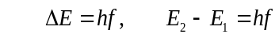  - the Bohr model of the hydrogen atom integrates light quanta and atomic energy states to explain the specific wavelengths in the hydrogen spectrum and in the spectra of other simple atoms; the Bohr model enables line spectra to be correlated with atomic energy-level diagrams | Chapter 8  p. 228 – 238 | Set 7.3  Chapter 7 Review Q’s on p.224 – 226  Set 8.1 | Task 3: Planck’s Constant experiment with in-class validation (5%)

9. Term 3 Week 4 (Wk 24)
Content | Text | Qns | Assessments
- on the atomic level, energy and matter exhibit the characteristics of both waves and particles. Young’s double slit experiment is explained with a wave model but produces the same interference and diffraction patterns when one photon at a time or one electron at a time are passed through the slits.  - on the atomic level, electromagnetic radiation is emitted or absorbed in discrete packets called photons. The energy of a photon is proportional to its frequency. The constant of proportionality, Planck’s constant, can be determined experimentally using the photoelectric effect and the threshold voltage of coloured LEDs  This includes applying the relationships | Chapter 8  p. 239 - 250 | Set 8.2  Chapter 8 Review Q’s p.252-254 | Task 8: Special Relativity and Quantum Physics Test (6%)

The Standard Model

The Big Bang theory describes the early development of the universe, including the formation of subatomic particles from energy and the subsequent formation of atomic nuclei. There is a variety of evidence that supports the Big Bang theory, including Cosmic Background Radiation, the abundance of light elements and the red shift of light from galaxies that obey Hubble’s Law. Alternative theories exist, including the Steady State theory, but the Big Bang theory is the most widely accepted theory today.

10. Term 3 Week 5 (Wk 25)
Content | Text | Qns | Assessments
The Standard Model  - high-energy particle accelerators are used to test theories of particle physics, including the Standard Model  This includes deriving and applying the relationship  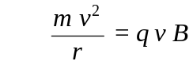 | Chapter 9  p.256 - 265 | Set 9.1  Set 9.2  Set 9.3

11. Term 3 Week 6 (Wk 26)
Content | Text | Qns | Assessments
- Lepton number and baryon number are examples of quantities that are conserved in all reactions between particles; these conservation laws can be used to support or invalidate proposed reactions. Baryons are composite particles made up of quarks  - the Standard Model is based on the premise that all matter in the universe is made up from elementary matter particles called quarks and leptons; quarks experience the strong nuclear force, leptons do not  - the Standard Model explains three of the four fundamental forces (strong, weak and electromagnetic forces) in terms of an exchange of force-carrying particles called gauge bosons; each force is mediated by a different type of gauge boson | Chapter 9  p.266 – 279  Chapter 10  p.284 - 297 | Set 9.4  Chapter 9 Review Q’s p.281-282  Set 10.1  Set 10.2 | Task 4: Evaluation and Analysis – Unit 4 Content – In-class hypothetical data evaluation and analysis (5%)

12. Term 3 Week 7 (Wk 27)
Content | Text | Qns | Assessments
- the expansion of the universe can be explained by Hubble’s law and cosmological concepts, such as red shift and the Big Bang theory  - the Standard Model is used to describe the evolution of forces and the creation of matter in the Big Bang theory | Chapter 10  p. 298 - 306 | Set 10.3  Chapter 10 Review Q’s p.309-310 | Task 9: Particle Physics and the Standard Model Test (6%)

13. Term 3 Week 8 (Wk 28)
Content | Text | Qns | Assessments
- Non-assessment week – revision for examination

14. Term 3 Weeks 9 (Wk 29)
Content | Text | Qns | Assessments
Semester 2 Mock WACE Examination (Unit 3 and 4 content) |  |  | Task 11: Semester 2 Mock WACE Examination (30%)

15. Term 3 Week 10 (Wk 30)
Content | Text | Qns | Assessments
Go through examination – revise for WACE examination

Term 4 structure - TBA

END OF UNIT

